DOCUMENTATION SET A

FIRST I TRIED set A where I haver to short a url

The code is uploaded with file name SET A URL.RAR(open in vscode)

I could only complete it till shortening it with mongodb

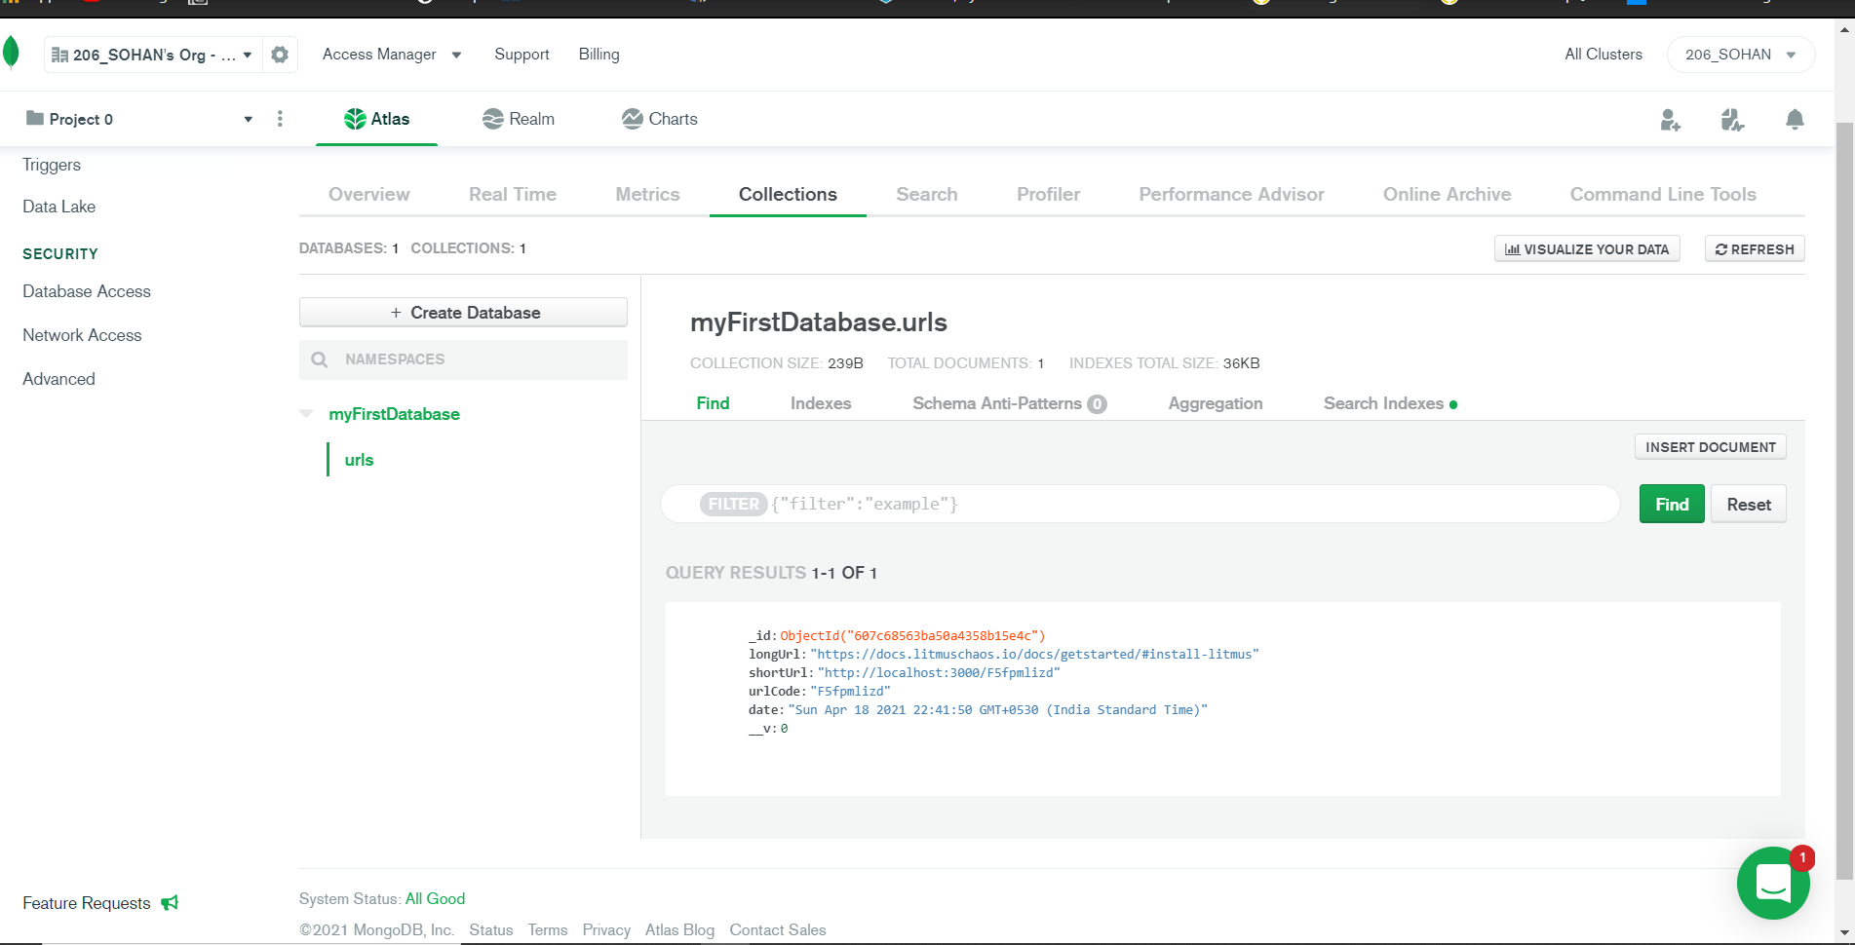

While trying to make it user interface I was facing problem so I went for set B